Transactions Letters

On Systematic Punctured Convolutional Codes

Min-Goo Kim

***Abstract—* This paper investigates high rate systematic punc- tured convolutional codes based on Forney’s results. High rate systematic punctured convolutional codes of rate-2/3 with con- straint length** 3 K 7 **and rate-3/4 through 15/16 with** K =7 **are derived using the rate-1/2 best known nonsystematic convolutional codes. Weight spectra of newly discovered system- atic punctured convolutional codes are provided and compared**

**with the best known nonsystematic punctured codes. Simulation results on bit-error probabilities (BEP’s) are also given.**

***Index Terms—* Punctured convolutional codes, Viterbi decod- ing.**

1. Introduction

**C**

ONVOLUTIONAL codes with Viterbi decoding have been widely used as an efficient and powerful class of

error correcting codes. An important subclass of convolutional codes is the class of systematic codes, where one output sequence is exact replica of the input sequence. There are two types of systematic encoder: feedforward and feedback [1]. The traditional systematic encoders are feedforward, which have not been widely used with Viterbi decoding. This is due to, as shown by Forney and Costello, their smaller minimum free distance  than nonsystematic feedforward encoder for a given rate and encoder memory [1]–[4]. In [1], Forney also showed that one can construct a systematic feedback encoder from nonsystematic feedforward encoder with identical dis- tance properties of nonsystematic feedforward encoders where feedback represents a division operation. Recently, recursive systematic convolutional (RSC) codes have been applied to turbo-codes by Berrou *et al*. [5]. RSC codes can be viewed as systematic codes with the feedback encoder given in [1]. Also, Couleaud *et al*. have proposed systematic convolutional codes with feedback encoder in [6].

For applications requiring high data transmission rate, pow- erful high rate convolutional codes are necessary. For efficient high rate codes, punctured convolutional codes have been widely used since they can significantly reduce the complexity of the Viterbi decoder. The punctured convolutional codes are obtained by periodically perforating code symbols from the output of a low rate- original code [7]–[9]. So far, most

Paper approved by T. Aulin, the Editor for Coding and Communications Theory of the IEEE Communications Society. Manuscript received August 17, 1995; revised February 2, 1996, and August 15, 1996.

The author is with the Department of Electronics Engineering, Seoul National University, Seoul 151-742, Korea. He is also with the Development Laboratory, Wireless Communication Division, Samsung Electronics Co. Ltd., Suwon, Korea.

Publisher Item Identifier S 0090-6778(97)01397-4.

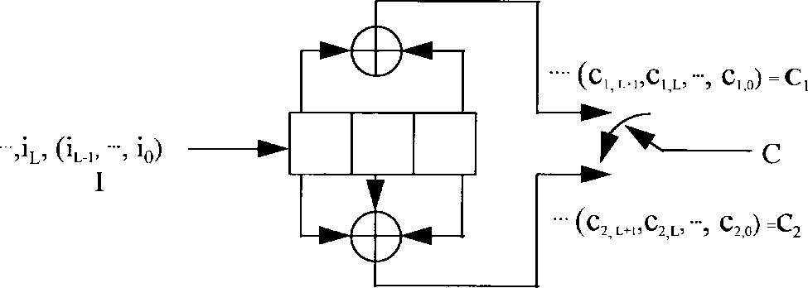

(a)

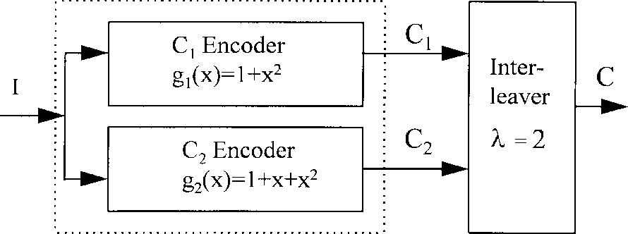

(b)

Fig. 1. Encoder for rate-1/2, K = 3, nonsystematic convolutional code with zero tail bits. (a) Typical encoder. (b) Equivalent encoder.

punctured convolutional codes use nonsystematic feedforward encoders for the well-known fact that the smallest number of information bit errors  along all incorrect paths of weight  increases when low rate- nonsystematic codes are converted to systematic codes [9]–[12]. However, in high rate punctured convolutional codes, this fact is not always true and systematic punctured codes appear to perform better than nonsystematic punctured convolutional codes.

This paper describes a method based on the Forney’s results

[1] for generating systematic convolutional codes from non- systematic convolutional codes by transforming information bits prior to encoding with the division operation to produce a systematic codeword using a nonsystematic feedforward encoder. By this method, we derive a class of systematic punctured convolutional codes. In addition, weight spectra of newly discovered systematic punctured convolutional codes are provided and compared with the best known nonsystematic punctured codes. It will be shown that high rate systematic punctured convolutional codes perform better than nonsystem- atic punctured codes. In Section II, we will briefly describe the proposed systematic convolutional codes construction methods and derive the weight spectra of the proposed systematic punctured convolutional codes. In Section III, bit-error prob- abilities (BEP’s) are analyzed on the additive white Gaussian noise (AWGN) channel for the proposed systematic punc-

0090–6778/97$10.00  1997 IEEE



(a) (b)

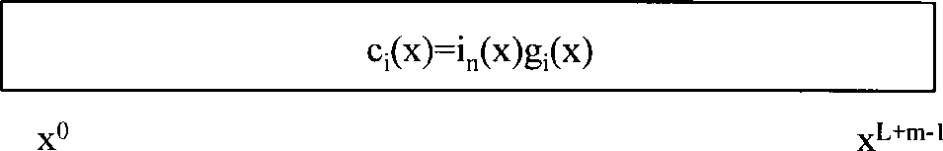

(c) Fig. 2. Bit structures of codewords: (a) cs (x), (b) c1(x), and (c) ci(x):

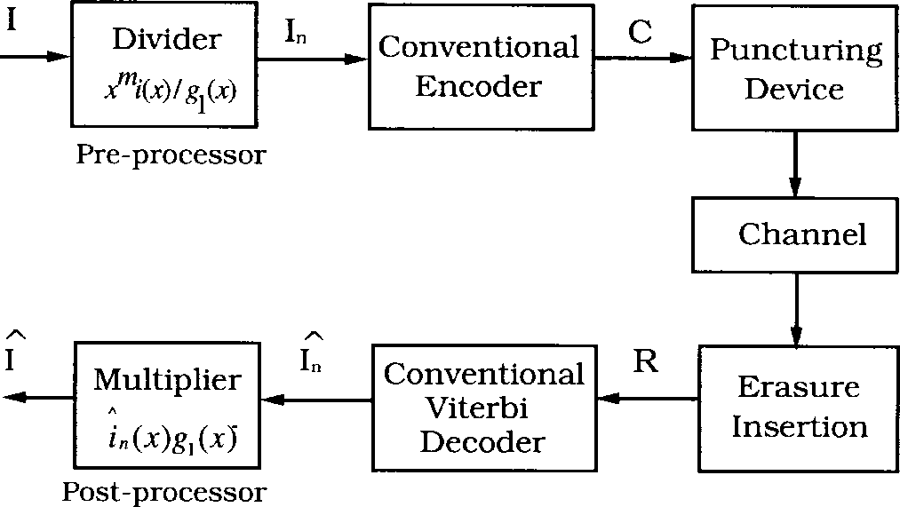tured convolutional codes and the best known nonsystematic convolutional codes.

1. Systematic Punctured Convolutional Codes

In this section, we briefly describe a method to generate rate- systematic convolutional codes based on the method given in [1]. Fig. 1 shows a feedforward encoder of rate-1/2, constraint length   , and memory    nonsystematic convolutional code with generator polynomials  and

given by

(1)



(2)



The arbitrary -input message bits are trans- formed into two output codewords and given by

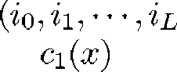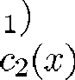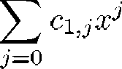

(3)



(4)

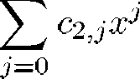

Fig. 3. Encoder and decoder of systematic punctured convolutional codes.

and generator polynomials  and  Let

 be nonsystematic codes generated by and , respectively. Assume that  is

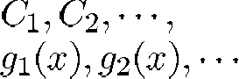

and

,

the arbitrary length of input message bits. Let  and  be the original input message word and polynomial, respectively, and be a message code containing unaltered input message bits. If is generated by  then the codeword of  is given by



where is the message polynomial given by



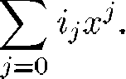

(5)

(6)

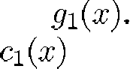where is the remainder of  [3], [4]. Due to linearity, and  have an identical set of codewords since both generator polynomials are Futhermore, there exists a nonsystematic codeword which is equal to such



In Fig. 1(a), one observes the output codeword  which is an interleaved   linear code of  and  with an interleaving depth of 2 [3], [4]. Fig. 1(b) shows an equivalent encoder of (a). Since any linear nonsystematic code



that

(7)

(8)

can be transformed into a systematic code with the same distance profile, these show that it is possible to construct systematic convolutional codes with the same distance profile of corresponding nonsystematic codes. In [1], it has been shown that systematic convolutional codes with a feedback encoder can be constructed from nonsystematic codes with a feedforward encoder.

1. *Rate-* *Systematic Convolutional Codes*

A method based on a canonical class of encoder for generat- ing systematic codes from feedforward nonsystematic codes is proposed [1]. Consider a rate- nonsystematic convolutional code with constraint length (or memory     )



although the message bits are different in each of them [3], [4]. From (6) and (7), we see that the original -input message bits  lie between the th bit and th bit in a nonsystematic codeword  This is clearly depicted in Fig. 2(a) and (b) in which gray blocks represent the original input message bits. If   , then Fig. 2(a) is equal to Fig. 2(b). Thus, without any loss of the input message bits, nonsystematic convolutional codes can be easily transformed into systematic convolutional codes.

Any  of  and  can be selected for the message code which determines its distance profile. Fig. 3 shows the encoder and decoder of proposed systematic con- volutional codes with a message code  The proposed

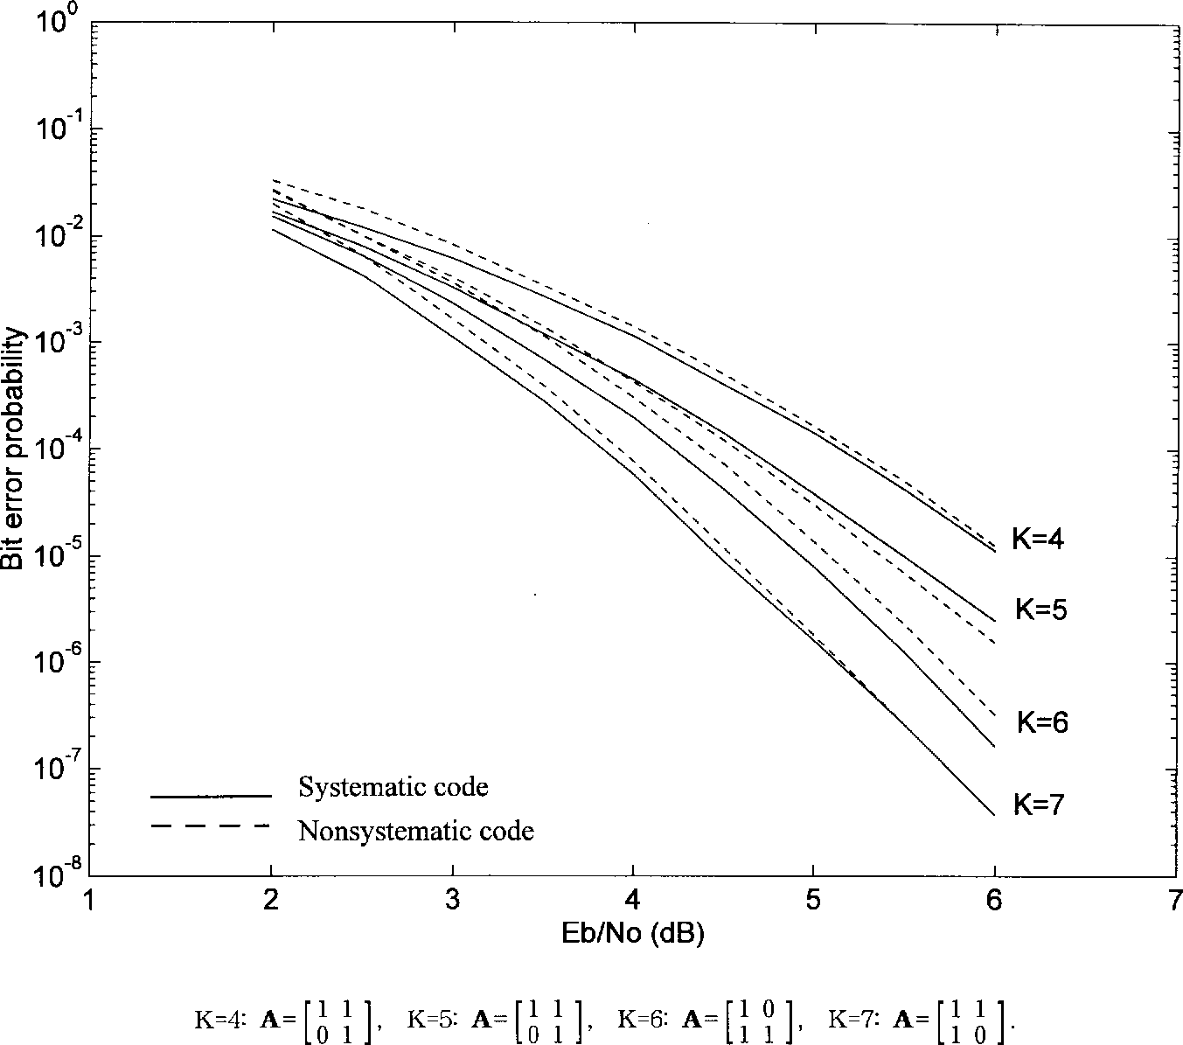

Fig. 4. BEP’s of rate-2/3 systematic and nonsystematic punctured convolutional codes.

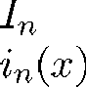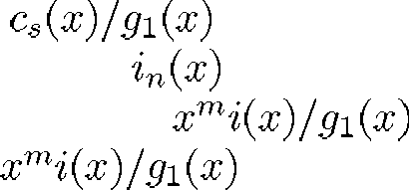encoder consists of a conventional encoder with a preprocessor performing and producing a new message word (or polynomial ). In Fig. 3, a preprocessor produces

by performing and transferring only the quotient of which is equal to  This decoder is a standard nonsystematic Viterbi decoder. A post- processor recovers the decoded sequence by performing



is

where    Zero elements of  denote the positions of punctured bits. We can obtain various rate- systematic convolutional codes from rate- systematic codes by select- ing  and  It has been well known that the conditions for choosing the puncturing matrix  is obvious: noncatastrophic property, maximum , and minimum  and  In addition, one condition that one row of  must have all ones is required

and dropping the terms of degree    *or*

for systematic form. In a convolutional code,

the number

*less*. Encoding/decoding are performed continuously. Note that the proposed scheme can be easily implemented with existing Viterbi decoders. The proposed systematic codes are similar to RSC codes with combined feedback and feedforward encoders. The difference is that RSC codes use  while the proposed systematic codes use  for a message code.

1. *High-Rate Systematic Punctured Convolutional Codes*

It is possible to find high rate systematic convolutional codes from nonsystematic convolutional codes directly through the same approach for generating rate-  systematic convolu- tional codes. However, it is more attractive and effective to use puncturing methods to obtain high rate convolutional codes where inherent difficulties of encoding and decoding can be almost resolved [3], [7]–[9].

Consider rate- systematic convolutional codes with a constraint length of Assume that  is a puncturing period and  is an    puncturing matrix which is given by



.



of incorrect paths of Hamming weight   that diverge from a correct path then remerge sometime later.  is the total number of information bit errors produced by incorrect paths [7]–[12]. In Fig. 3, the encoder and decoder of high rate punctured systematic convolutional codes are shown. The conventional encoder and decoder are modified by insertion of a puncturing device and an erasure-inserting device [7].

In the proposed systematic codes, error event probability  is the same as that of the corresponding nonsystematic codes since the two codes have the same set of codewords. However, each possess different BEP  because the weight spectra of information bits in the codes are different [2]–[4].

1. *Weight Spectra of Systematic Punctured Convolutional Codes*

The proposed rate- systematic convolutional code have same distance profile of corresponding nonsystematic convo- lutional codes due to identical generator polynomials. When







. .



.



(9)

the fact that classical feedforward systematic convolutional codes have a smaller  than nonsystematic convolutional codes is considered, the proposed systematic codes show an

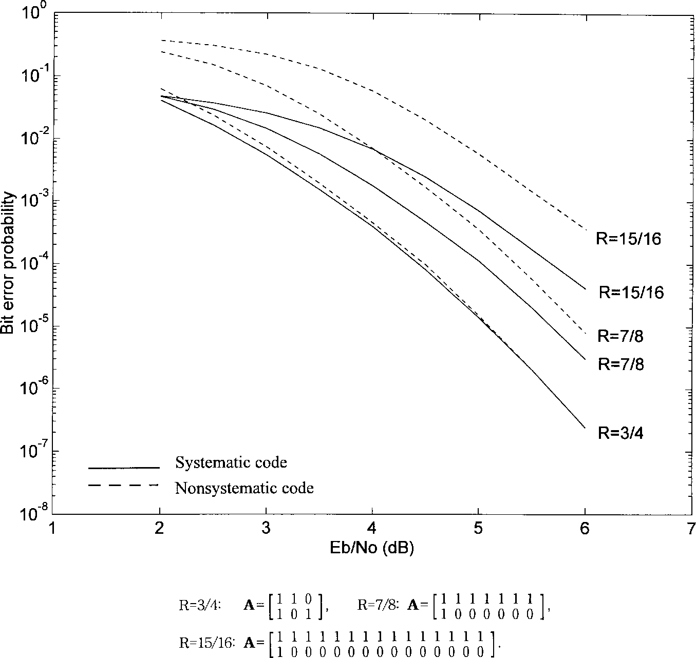

Fig. 5. BEP’s of systematic and nonsystematic punctured convolutional codes. Code rate R = p=(p + 1);p = 3; 7; 15: K = 7:

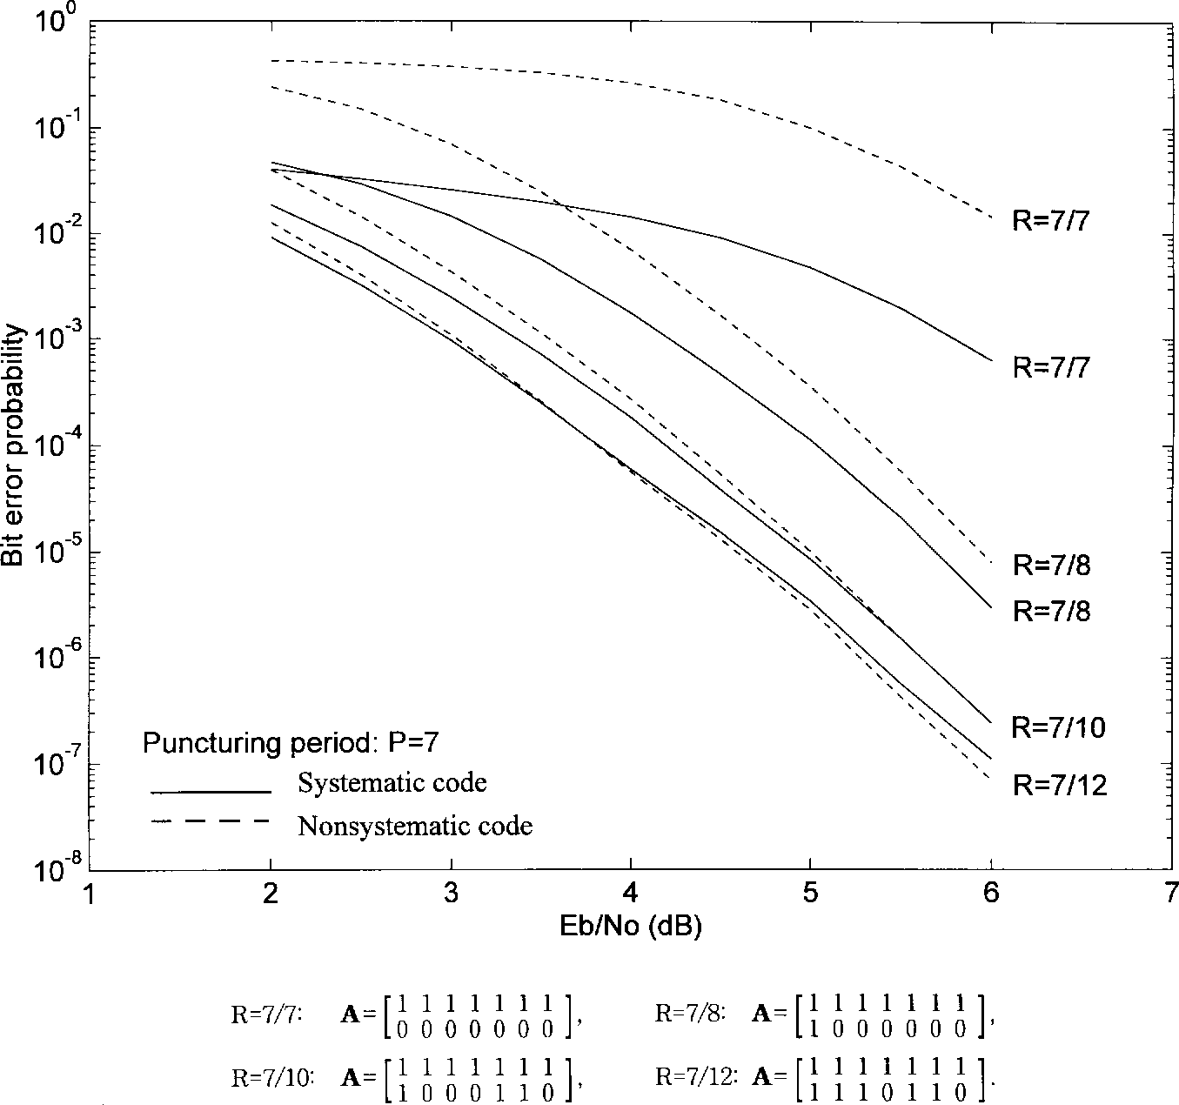

Fig. 6. BEP’s of systematic and nonsystematic punctured convolutional codes. Code rate R = 7=(7 + s);s = 0; 1; 3; 5: K = 7:

TABLE I

Weight Spectra of Rate-2/3 Systematic Punctured Convolutional Codes Generated from the Best Known Rate-1/2 Code of

3 K 7 AND P = 2

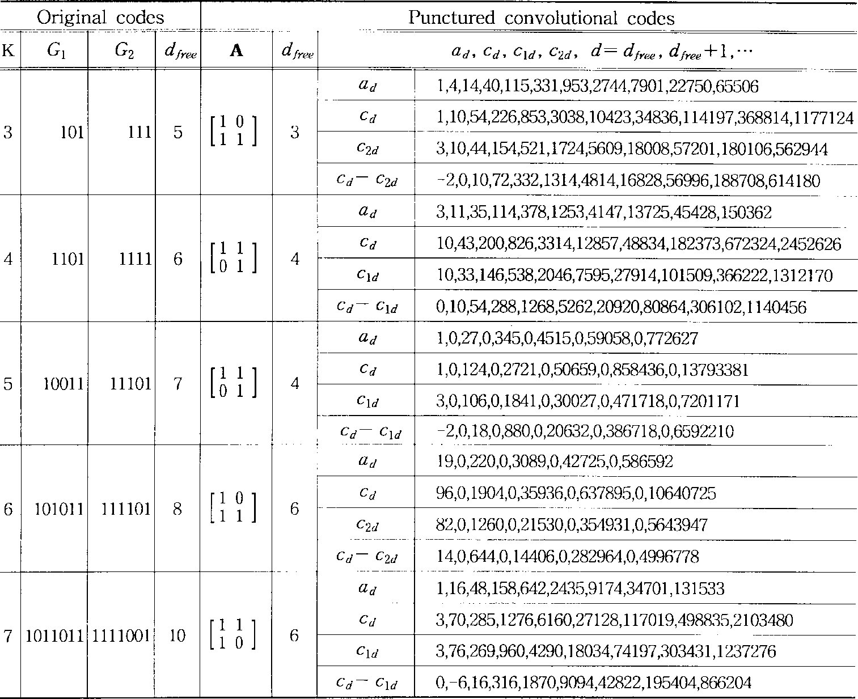

attractive advantage [2]–[4]. Next, consider the weight spectra of punctured convolutional codes. The results in Tables I and

II have been derived using the assumption that a decoder works on the low rate trellis of the original code as in [12]. Table I lists rate-2/3 systematic punctured convolutional codes generated from the best known rate-1/2 codes.  and  denote the generator polynomial coefficients of the original rate-1/2 codes. In Table I,   , denotes the total number of information error bits when one of    is selected for a message code. Table I shows that the proposed systematic punctured codes have lower  than nonsystematic

punctured codes except for three cases:  for   

high  Also, Table II shows that, at low  all systematic punctured codes perform better than nonsystematic codes. Another interesting result is that, for   and

,  (or  is smaller than  of nonsystematic codes with the best known nonsystematic puncturing matrices denoted by “*.”

1. Simulation Results and Discussion

We simulated performances of a number of punctured con- volutional codes on the AWGN channel with binary phase shift keying modulation. A Viterbi decoder is used with unquantized

for    differences o



and f

for

they are small.

  Table I also shows that the

(or ) are positive although



matched filter soft decision inputs. Fig. 4 shows BEP’s  of    proposed systematic codes and nonsystematic codes. A gain of 0.2 dB has been obtained for   

Table II lists the weight spectra of systematic punctured convolutional codes generated from the best known rate- 1/2 code of    for various puncturing period  For   and , Table II lists the two different weight spectra according to puncturing matrices such that one is the proposed systematic puncturing matrix and the other is the best known nonsystematic puncturing matrix. It is shown that  (or ) becomes smaller than  as  increases or  increases for a fixed  In fact, for   , differences between  and  are large and all positive. This implies that  of the systematic punctured code with    and rate-15/16 is significantly lower than nonsystematic code at both low and

for   , and that simulation results and the weight spectra of Table I are in good agreement. For   , the performance improvement of proposed systematic codes is minimal. To investigate the possible gains for high rate systematic punctured convolutional codes, BEP’s for  

  and  were examined through simulation. Fig. 5 shows that systematic codes perform better than nonsystematic codes at both low and high The improvement increases as the code rate increases. For



and , gains of 0.3 and 0.6 dB are obtained respectively at  Fig. 6 shows  of the systematic and nonsystematic punctured codes with    for fixed    and various     It also shows that,



TABLE II

Weight Spectra of Systematic Punctured Convolutional Codes Generated from the Best Known Rate-1/2 Code of K = 7: G1 = [1011011]; G2 = [1111001]

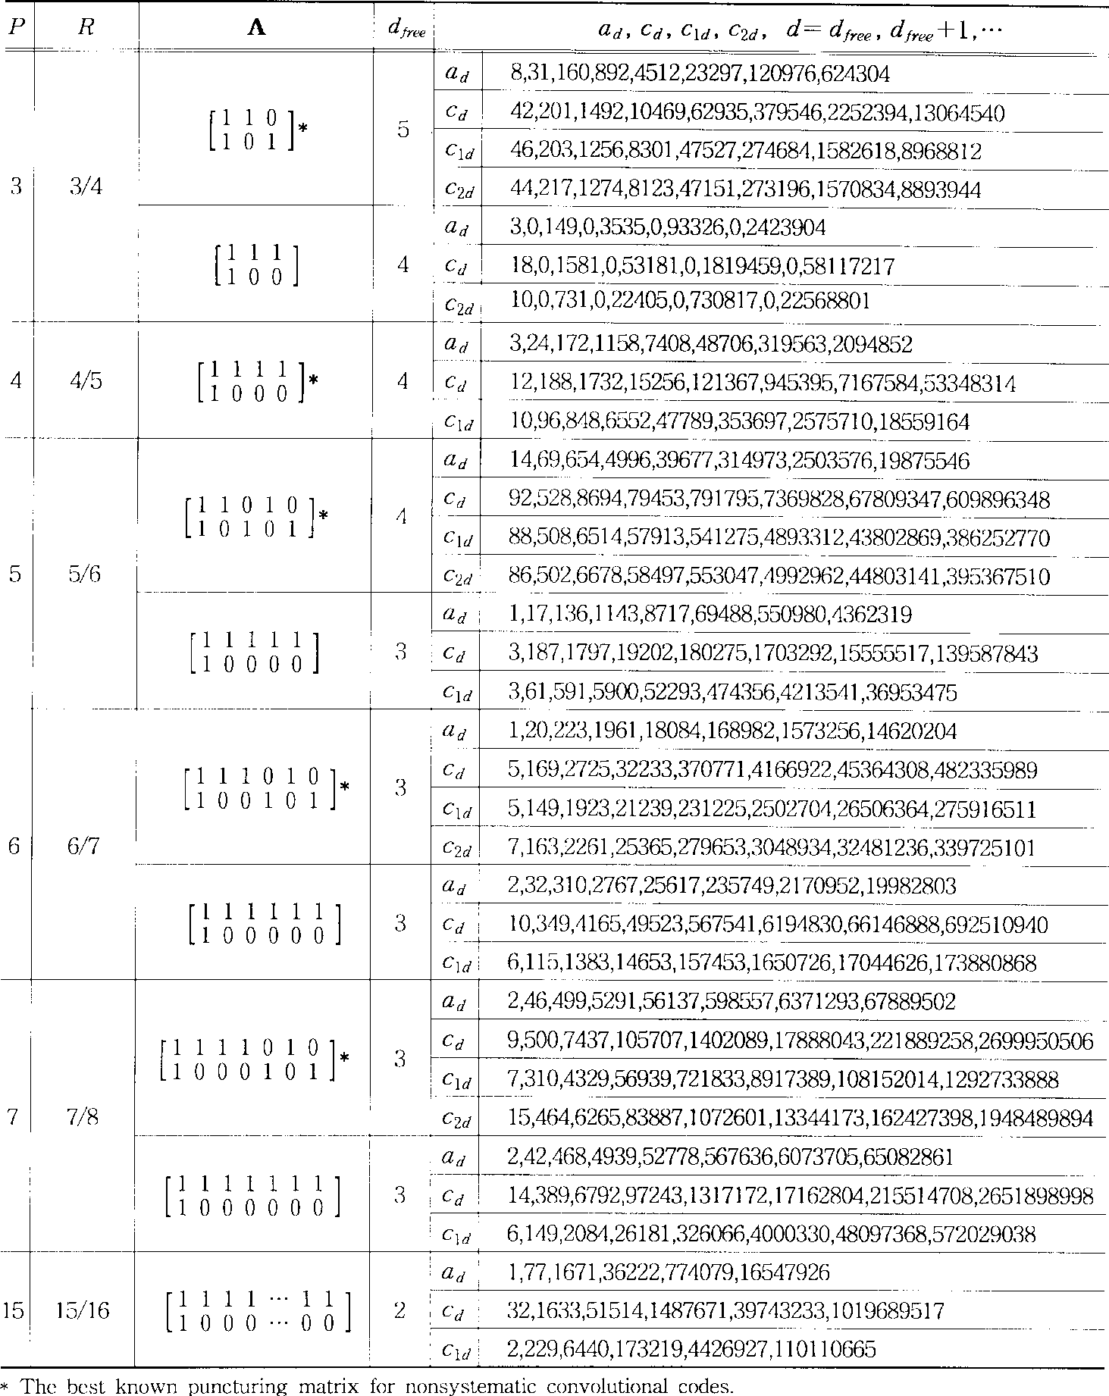

at increasing code rate, the systematic punctured convolutional codes perform better than the nonsystematic codes.

1. Summary and Conclusions

In this paper, we have derived good high rate system- atic punctured convolutional codes and analyzed their weight spectra and BEP performance. It was shown that high rate systematic punctured convolutional codes perform better than nonsystematic punctured convolutional codes as the code rate increases for constraint length      For      and , the proposed systematic punctured convolutional codes provided better performance than the best known nonsystematic punctured convolutional codes. Simulation results of BEP showed good agreement with weight spectra results. In comparing nonsystematic punctured codes with   , rate-7/8 and 15/16, corresponding systematic

punctured codes demonstrated 0.3 and 0.6 dB improvements, respectively, at   

Acknowledgment

The authors would like to thank the anonymous reviewers for their extensive and helpful comments.

References

1. G. D. Forney, Jr., “Convolutional codes I: Algebraic structure,” *IEEE Trans. Inform. Theory*, vol. IT-16, pp. 720–738, Nov. 1970.
2. A. J. Viterbi and J. K. Omura, *Principles of Digital Communication and*

*Coding*. NY: McGraw-Hill, 1979.

1. S. Lin and D. J. Costello, Jr., *Error Control Coding: Fundamentals and Applications*. Englewood Cliffs, NJ: Prentice-Hall, 1983.
2. R. E. Blahut, *Theory and Practice of Error Control Codes*. Reading,

MA: Addison Wesley, 1983.

1. C. Berrou, A. Glavieux, and P. Thitimajshima, “Near Shannon limit error-correcting coding and decoding: Turbo-Codes,” in *Proc. IEEE ICC’93*, Geneva, Switzerland, 1993, pp. 1064–1070.
2. J. Y. Couleaud and S. S. Pietrobon, “High gain coding schemes for space

communications,” *IEEE Trans. Commun.*, submitted for publication.

1. J. B. Cain, G. C. Clark, and J. M. Geist, “Punctured convolutional codes of rate (n 1)=n and simplified maximum likelihood decoding,” *IEEE Trans. Inform. Theory*, vol. IT-25, pp. 97–100, Jan. 1979.
2. Y. Yasuda, K. Kashiki, and Y. Hirata, “High rate punctured convolu- tional codes for soft-decision Viterbi decoding,” *IEEE Trans. Commun.*, vol. COM-32, pp. 315–319, Mar. 1984.
3. K. J. Hole, “New short constraint length rate (N 1)=N punctured convolutional codes for soft-decision Viterbi decoding,” *IEEE Trans. Inform. Theory*, vol. IT-34, pp. 1079–1081, Sept. 1988.
4. J. Hagenauer, “Rate-compatible punctured convolutional codes (RCPC) codes and their applications,” *IEEE Trans. Commun.*, vol. 36, pp.

389–400, Apr. 1988.

1. S. Kallel and D. Haccoun, “Generalized type II hybrid ARQ scheme using punctured convolutional coding,” *IEEE Trans. Commun.*, vol. 38,

pp. 1938–1946, Nov. 1990.

1. G. Begin, D. Haccoun, and C. Paquin, “Further results on high-rate punctured convolutional codes for Viterbi and sequential decoding,” *IEEE Trans. Commun.*, vol. 38, pp. 1922–1928, Nov. 1990.